**SE185: Problem Solving in Software Engineering**

**Quiz # 7 (200 points)**

|  |  |
| --- | --- |
| Name: Adam Jennissen | Name: |

Answer the following questions and make a pdf file that includes the **source code, sample inputs, and outputs**. You must submit the **pdf file and all of the .c files** on Canvas for full credit. Do not forget to add your group partner name on the pdf file and the source codes.

1. **(50 points)** Write a complete C program that declares an integer called num and initialize it to 5. Create an integer pointer variable called myPtr that stores the memory address of num. Print the memory addresses of num and myPtr, the values stored in num and myPtr, and the value that myPtr points to in this format:

|  |
| --- |
| num is stored at: ____  myPtr is stored at: ____  num holds the value: ____  myPtr holds the value: ____  myPtr points to this value: ____ |

Hint: The value that num holds and value that myPtr points to are equal.

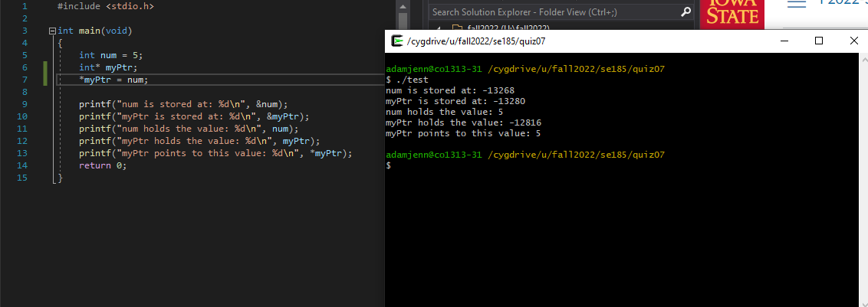

1. **(50 points)** Re-implement the following code by defining int copy_a as an integer pointer variable called ptr_a. Keep int as an integer variable.

|  |
| --- |
| #include<stdio.h>  int main() {  int a = 15;  int copy_a = a;  a /= 3;  copy_a = a;  copy_a++;  a = copy_a;  if(copy_a == a) {  printf(“Copy_a = %d\n” , copy_a);  printf(“a = %d\n” , a);  printf(“Therefore, copy_a = a = %d\n” , copy_a);  }  return 0;  } |

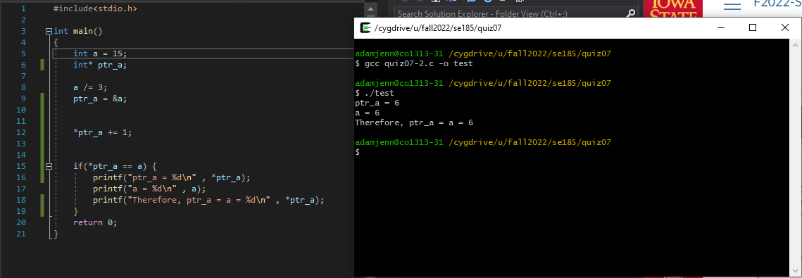

**Inputs and outputs format:**



1. **(100 points)** Write a complete C program that ask users to enter midterm 1 exam score for 30 students. Your program then calculates following exam statistics and print the result.
2. Midterm 1 exam average
3. Maximum score
4. Minimum score
5. Number of students fail (<60)
6. Number of students got A (93+)

**Your program must meet the following requirements:**

1. Store the user inputs (midterm 1 exam scores) to an array named **midterm1Score**
2. You must use a user defined function named **examStat** to calculate the exam statistics, and save the result to an array named **result**.

* When you call the function, you must **pass four arguments** including **two arrays and the size of the two arrays**.
* Calculate the exam statistics (mentioned above), and **save the result to an array**.

1. Print the exam statistics from the array named **result**.

